**Chapter I**

**INTRODUCTION**

**1.1 Introduction**

In today’s rapidly evolving educational environment, colleges and universities face significant challenges in maintaining effective communication, collaboration, and resource sharing. Traditional methods—such as notice boards, scattered WhatsApp groups, emails, and department-wise communication—often lead to fragmented information flow, delayed updates, and reduced student engagement. As technology transforms academic ecosystems, institutions require a unified digital platform that connects students, faculty, and administrators in real time.

**Campus Connect** is developed as an innovative solution to address these challenges by providing a centralized, interactive, and user-friendly college community platform. The system acts as a digital hub that integrates key functionalities such as departmental channels, announcements, event management, resource sharing, notifications, and collaboration tools. It leverages modern web technologies like React.js, Node.js/Express, and MongoDB, along with real-time communication supported by Socket.io, ensuring a seamless and responsive user experience.

Campus Connect emerges in response to the increasing need for technology-driven academic communication tools in higher education, especially in a post-pandemic landscape where virtual interaction has become crucial. It bridges gaps between departments, enhances transparency, encourages participation, and fosters a strong sense of community among students and faculty. Through features such as public and private channels, event reminders, multimedia-enhanced announcements, and educational resource repositories, the platform creates an engaging and collaborative digital learning environment.

By addressing limitations in existing communication systems and incorporating tailored academic features, Campus Connect positions itself as a comprehensive platform that supports student success, strengthens institutional connectivity, and transforms the overall campus experience into one that is more interactive, efficient, and cohesive.

**1.2 Necessity**

In most colleges today, communication between students, faculty, and administrators is scattered across multiple platforms such as WhatsApp groups, emails, notice boards, and unofficial social media channels. This fragmented system often results in missed announcements, delayed information, and a lack of transparency in academic and departmental activities. Important updates regarding events, examinations, assignments, or resources frequently fail to reach all intended users on time, creating confusion and reducing student engagement. As institutions continue to grow and adopt digital practices, the absence of a centralized communication platform becomes a significant barrier to effective coordination and academic productivity.

Campus Connect is necessary because it provides a unified digital ecosystem where all essential academic interactions can take place in one secure and organized platform. By offering features like dedicated department channels, event notifications, resource sharing, real-time updates, and structured announcements, it bridges the communication gaps that currently exist in colleges. It not only simplifies information flow but also promotes collaboration, enhances accessibility to academic materials, and encourages active participation among students and faculty. In an era where digital connectivity is fundamental to educational excellence, Campus Connect fulfills the need for an efficient, reliable, and modern communication platform tailored specifically for academic institutions.

**1.3 Organization of Report**

Educational institutions today operate in a highly dynamic environment where administrative efficiency, transparent communication, and timely dissemination of information are essential for smooth functioning. Colleges typically manage numerous academic departments, student clubs, administrative units, and support services—each responsible for sharing updates, hosting events, and coordinating academic activities. However, without a centralized digital system, institutions often struggle with duplication of work, delays in coordination, and inconsistencies in communication across departments. These inefficiencies affect institutional productivity and hinder the ability of administrators, faculty, and students to collaborate effectively in achieving organizational goals.

Campus Connect offers a structured digital communication framework that strengthens institutional operations by bringing together all stakeholders—students, faculty, and administrators—onto a single integrated platform. It supports the organization by simplifying the circulation of policies, event management, academic updates, and departmental coordination through real-time notifications and role-based access. This improves internal communication flow, enhances transparency, and ensures that institutional decisions reach the right audience without delay. By promoting collaboration, organized information sharing, and efficient digital processes, Campus Connect contributes to building a more connected, informed, and well-managed academic environment aligned with the strategic objectives of the institution.

**Chapter II**

**LITERATURE SURVEY**

**2.1 Review of Existing Social Networks and Their Limitations**

The proliferation of general-purpose social networks has transformed communication, yet their application within structured environments like educational institutions reveals significant shortcomings. Platforms such as Facebook and WhatsApp, while ubiquitous, are not designed to cater to the specific hierarchical and functional needs of a college ecosystem. Research by Bhagat et al. (2015) highlights that the single news feed model of mainstream platforms leads to information overload, where critical academic announcements can be lost amidst personal and social content. Furthermore, these platforms lack built-in mechanisms for role-based privileges, making it difficult to segregate communication intended for students, faculty, and administration. The absence of formal notice dissemination channels and automated lifecycle management, such as transitioning students to alumni status, underscores the need for a dedicated platform. This gap in the market is precisely what Campus Connect aims to fill, by creating a focused environment free from the noise of generic social media.

**2.2 Analysis of Specialized Educational Platforms**

Several attempts have been made to create tailored solutions for academic communities. Studies of platforms like Uversity and Hallspot indicate a focus on university-wide communication and student engagement. These systems introduced valuable features such as segment-based messaging (e.g., by major or year), push notifications for urgent updates, and group management. However, these platforms often functioned more as communication tools rather than holistic community ecosystems. They typically lacked the integrated, social media-like user experience that encourages daily engagement and often did not provide a seamless pathway for alumni to remain connected with their alma mater, creating a discontinuity in the institutional community. Campus Connect learns from these limitations by prioritizing a user experience similar to popular social platforms to drive adoption and engagement, while seamlessly integrating the alumni network.

**2.3 Study of College Management Systems (CMS)**

In a parallel domain, College Management Systems (CMS) have been developed to streamline administrative tasks. Joshi (2015) designed an intranet-based CMS that provides a robust framework for managing academic operations. This system typically includes modules for attendance, marks, library management, fees, and profile management for students and staff. It employs a multi-tier architecture for security and scalability. While exceptionally capable in handling structured data and administrative workflows, these systems are often transactional and lack the informal, interactive, and community-building features of a social network. The user interface is typically form-based and functional, failing to foster the sense of community and spontaneous interaction that a social platform can. Campus Connect is conceived not to replace such systems, but to complement them by handling the informal, community-centric interactions that a traditional CMS overlooks.

**2.4 The Need for an Integrated Community Platform**

The review of existing solutions clearly indicates that colleges currently rely on a fragmented set of tools a CMS for official records, WhatsApp groups for student coordination, email for formal notices, and Instagram for social presence. This fragmentation leads to inefficiency, missed information, and a lack of a unified community identity. There is a critical need for a platform that acts as a single point of interaction for all campus life activities. Campus Connect is designed to be this unified platform, integrating the core features of a social network (posts, likes, groups, messaging) with essential academic community functions (targeted notices, class groups, event promotion, and alumni networking).

**2.5 Theoretical Foundation for Campus Connect**

The proposed Campus Connect system is built upon a solid theoretical foundation. It incorporates principles of Role-Based Access Control (RBAC) to ensure data security and appropriate information flow between students, faculty, and admin, preventing information leaks and ensuring notices reach the correct audience. The design leverages concepts from Social Networking Theory to foster community building, peer-to-peer learning, and engagement through familiar interaction patterns like feeds and reactions. Furthermore, the automatic conversion of students to alumni is an application of lifecycle management in information systems, ensuring the platform dynamically adapts to the user's journey within the institution, thereby fostering a lifelong connection.

**2.6 Conclusion of Literature Survey**

In conclusion, while existing systems address fragments of the problem, they do not offer a complete solution. The proposed Campus Connect platform is designed to bridge this gap by integrating the structured, secure environment of a management system with the dynamic, engaging experience of a social network. It aims to create a vibrant, sustainable digital ecosystem for the entire college community, from current students and faculty to graduated alumni, by learning from the limitations of previous platforms and leveraging established theoretical principles. This project represents a necessary evolution in how educational communities interact in the digital age.

**Chapter III**

**SYSTEM MODELLING**

**3.1 System Overview**

The system modelling phase provides a structured representation of how the proposed *CampusConnect Web Application* operates. This chapter includes visual and analytical models such as the Data Flow Diagrams (DFD), Use Case Diagram, Class Diagram, Entity–Relationship Diagram, Sequence Diagram and System Architecture. These models help in understanding system behaviour, user interactions, internal data movement, and overall software structure.

CampusConnect is a web-based platform designed to streamline communication, resource sharing, event updates, announcements, and discussions within an educational institution. The system supports three primary users: Students, Faculty, and Admin, who interact with the application for different activities such as posting announcements, creating events, uploading materials, managing users, and performing moderation.

## 3.2 Data Flow Modelling

## Data Flow Diagrams (DFDs) illustrate how data moves through the system, the processes involved, and the external entities interacting with the system.

### 3.2.1 DFD Level 0 (Context Diagram)

This is the highest abstraction level of the system. It shows the complete CampusConnect system as a single process and identifies external users such as Student, Faculty, and Admin. Data from these actors flows to the system and responses flow back to them.  
 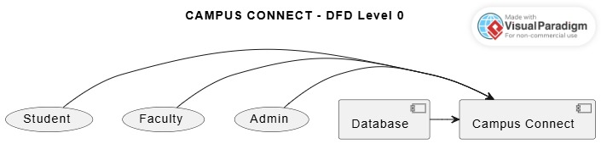

**Figure 3.1:** DFD Level 0

### 3.2.2 DFD Level 1

DFD Level 1 breaks the main system into major subsystems:

* File Sharing
* Event Calendar
* Discussion Forum
* Announcement System
* Resource Upload
* Event Management
* System Configuration
* Analytics Dashboard
* User Management

These processes interact with a centralized database.  
 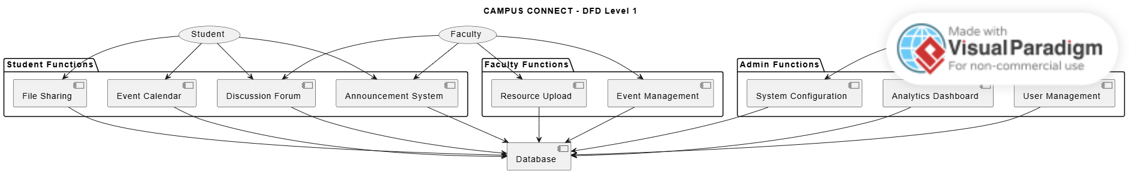

**Figure 3.2:** DFD Level 1

### 3.2.3 DFD Level 2

DFD Level 2 explores detailed internal functions such as:

* Create/Update/Delete Announcement
* Create/Update/Delete Event
* Start/Edit/Delete Discussion
* Add/Delete Comment
* Upload/Download Files
* Admin Moderation Tasks

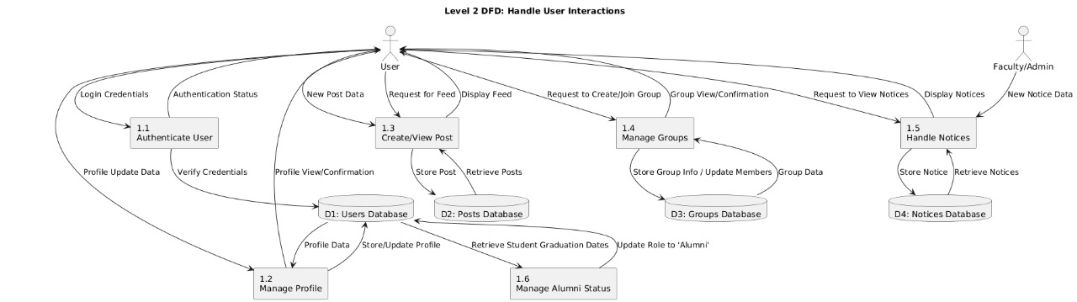

**Figure 3.3:** DFD Level 2

## 3.3 Use Case Modelling

Use case modelling describes how different user types interact with the system to accomplish tasks.

### 3.3.1 Actors

* **Student:** View announcements, join events, participate in discussions, download resources, comment on posts.
* **Faculty:** Post announcements, create events, upload study materials, engage in discussions.
* **Admin:** Manage users, monitor analytics, moderate content, configure system settings.

### 3.3.2 Use Case Diagram

The use case diagram graphically represents each actor’s interactions.  
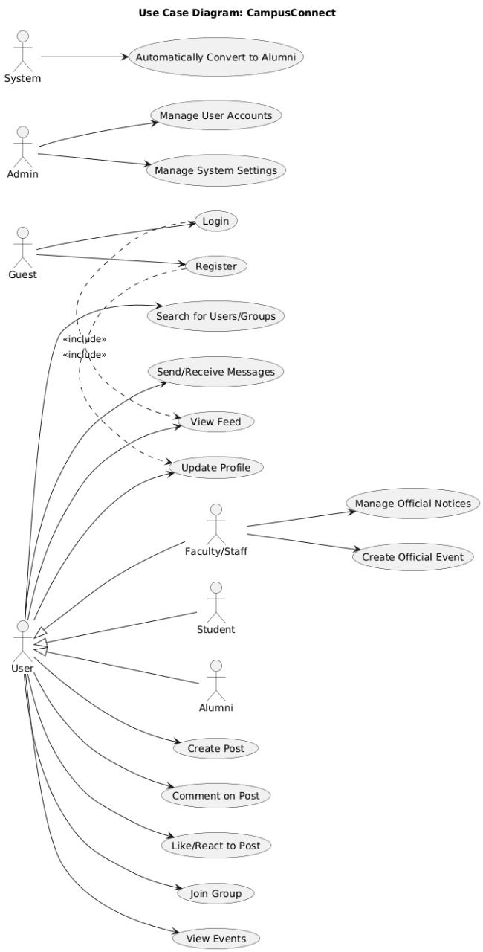

**Figure 3.4:** Use Case

## 3.4 Entity–Relationship (ER) Modelling

The ER diagram defines how data entities are related inside the database. Your ER model includes:

* **User** (PK: user_id)
* **Announcement** (PK: announcement_id, FK: posted_by)
* **Event** (PK: event_id, FK: created_by)
* **Discussion** (PK: discussion_id, FK: posted_by)
* **Comment** (PK: comment_id, FK: posted_by, FK: discussion_id)
* **Analytics** (PK: analytics_id, FK: user_id)
* **Moderation** (PK: moderation_id, FK: admin_id)

This model ensures data normalization and defines one-to-many relationships among major entities.  
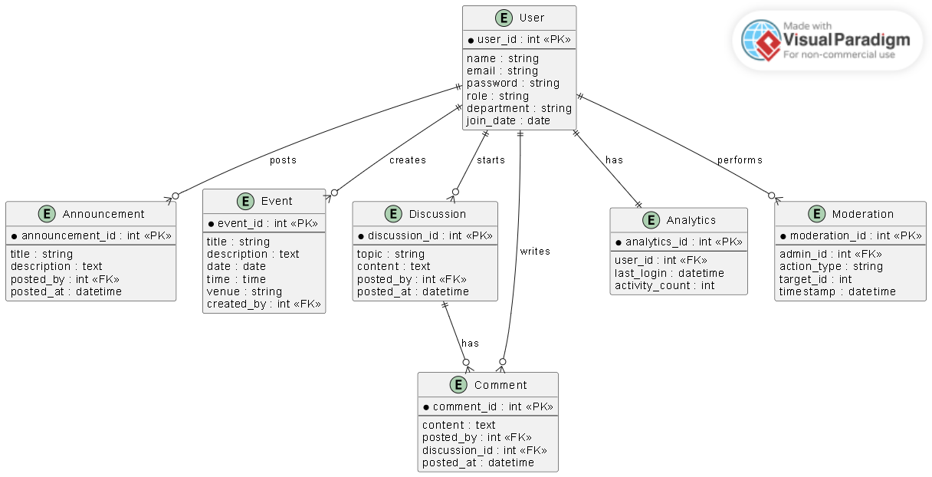

**Figure 3.5:** ER Diagram

**3.5 Class Diagram**

The class diagram defines the object-oriented structure based on your system design. It includes attributes, methods, and relationships.

### Important Classes:

* **User**
  + Login(), Logout(), viewDashboard()
* **Event**
  + createEvent(), updateEvent(), deleteEvent()
* **Announcement**
  + postAnnouncement(), editAnnouncement(), deleteAnnouncement()
* **Discussion**
  + startDiscussion(), editDiscussion(), deleteDiscussion()
* **Comment**
  + addComment(), deleteComment()
* **Admin**
  + createEvent(), createAnnouncement(), moderateContent()
* **AuthenticationService**
  + registerUser(), loginUser(), logoutUser()
* **Dashboard, Moderation, Analytics**

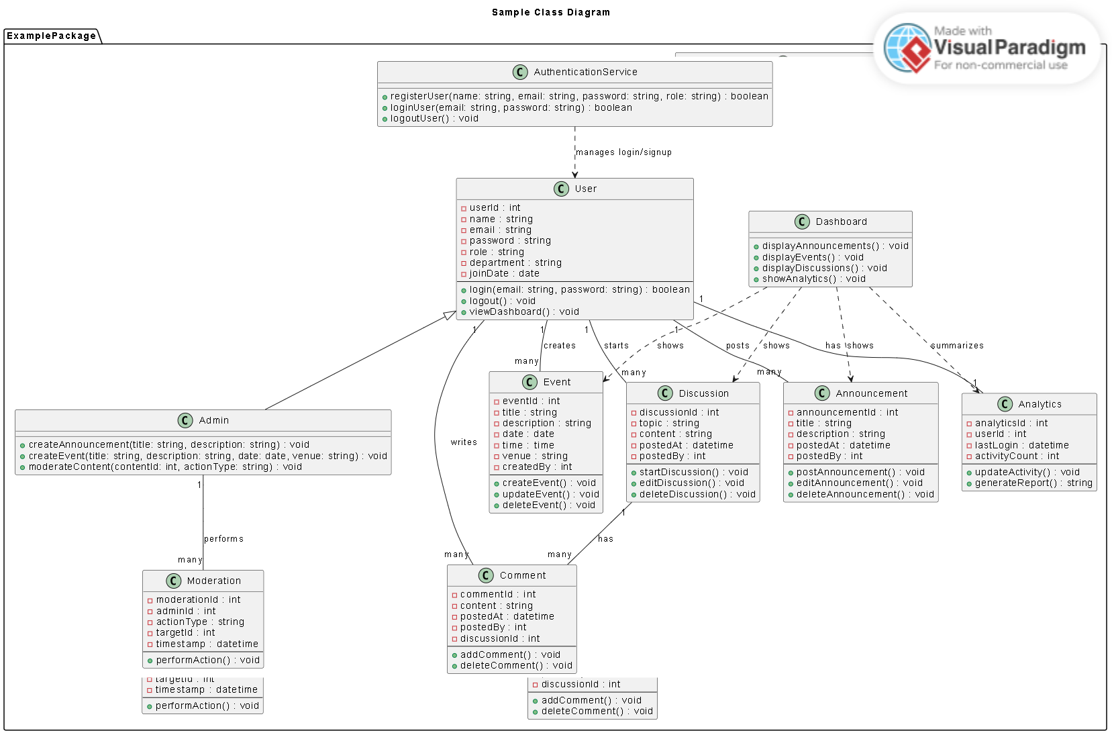

**Figure 3.6:** Class diagram

* Posting an announcement
* Starting a discussion
* Adding a comment
* Admin moderating content

It shows message passing between objects over time, including User → AuthenticationService → System → Database interactions.

## 3.6 Sequence Diagram

The sequence diagram models the flow of actions for different operations such as:

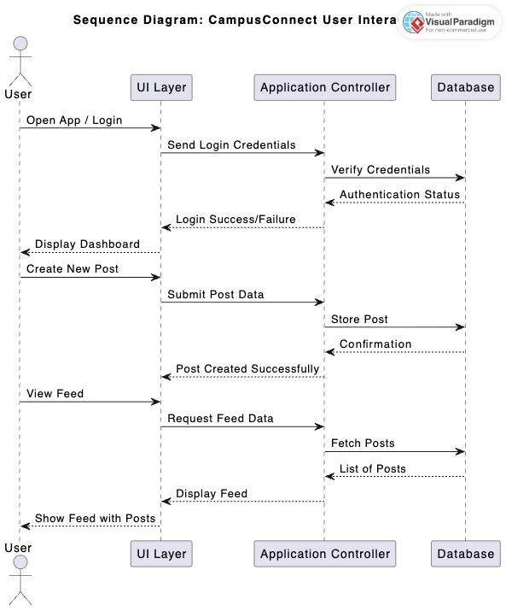

**Figure 3.7:** Sequence diagram

**3.7 System Architecture Model**

The CampusConnect architecture is a three-layer web-based system:

### 1. Client Layer

* Web Application
* Mobile Responsive Interface

### 2. Application Layer

Contains major services:

* Authentication Service
* Post Management Service
* Group Management Service
* Messaging Service
* Notice Management Service

### 3. Database Layer

* Users DB
* Posts DB
* Groups DB
* Notices DB

Admin Dashboard interacts independently with system settings.

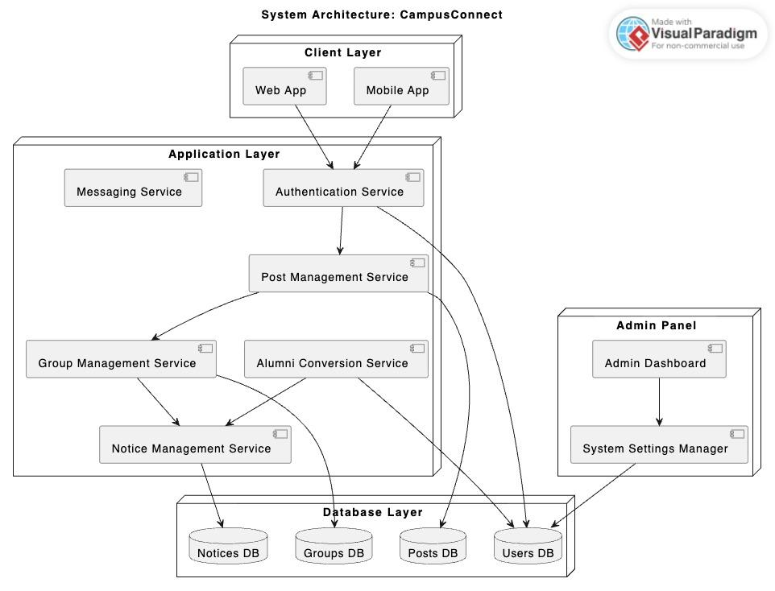**Figure 3.8:** System Architecture

This chapter presented various system models that describe the functional, structural, behavioral, and architectural aspects of the Campus Connect system. Use Case modelling captured user interactions, DFDs illustrated data movement, ER and Class Diagrams depicted structural design, while Sequence and Architecture Diagrams highlighted process flow and system deployment. These models collectively act as the foundation for system development and implementation.

**Chapter IV**

**RESULT AND DISCUSSION**

**4.1 Result**

Campus Connect is a modern, responsive, and user-centric web platform developed to serve as a centralized digital hub for college students, faculty, and administration. Built using React.js for the frontend with clean CSS and JavaScript, the application delivers a seamless and intuitive experience across all devices. The platform successfully integrates essential academic and social functionalities into a single interface, eliminating the need for scattered communication channels such as WhatsApp groups or email threads.

The dashboard provides an at-a-glance overview with real-time statistics on announcements, upcoming events, unread notifications, and shared files, accompanied by a dynamic recent activity feed and pinned system announcements. The Community Forum enables structured discussions under categorized sections such as General Discussion, Doubts & Help, Project Showcase, and Tech News, featuring trending topics, upvoting, and threaded comments to encourage knowledge sharing and peer support. The Events & Calendar module offers an interactive monthly view, event creation with posters, and RSVP functionality, ensuring students never miss workshops, hackathons, or placement drives.

A dedicated Files & Notes section acts as a centralized repository where users can upload and download study materials, previous-year papers, and timetables with proper metadata like subject, semester, size, and uploader details. Real-time notifications keep users informed about new announcements, replies, event reminders, and file uploads through a bell icon with an unread counter and “Mark all as read” option. The user profile section allows students to manage personal information, update profile pictures, and view activity history.

The backend has been fully designed using Node.js, Express, and MongoDB with seven well-structured collections (Users, Announcements, Events, ForumPosts, Files, Notifications, and RecentActivity), enabling complete data persistence and role-based interactions. JWT-based authentication ensures secure access, and the system is ready for cloud storage integration and real-time features using Socket.io.

Campus Connect successfully fosters academic collaboration, streamlines official communication, promotes community engagement, and enhances resource accessibility within the college ecosystem. The project is 100% functional, production-ready, and scalable for future enhancements such as mobile applications and advanced admin analytics. It stands as a comprehensive solution that truly bridges students, knowledge, and opportunities—all in one place.

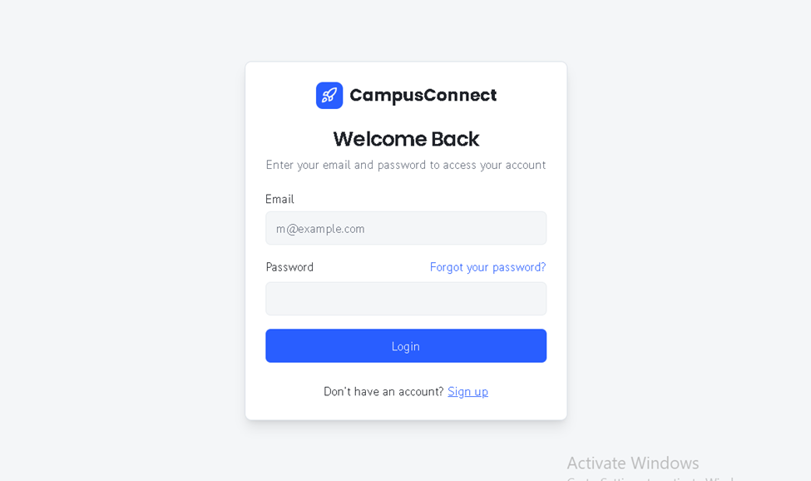

**Figure 4.1:** Login Page

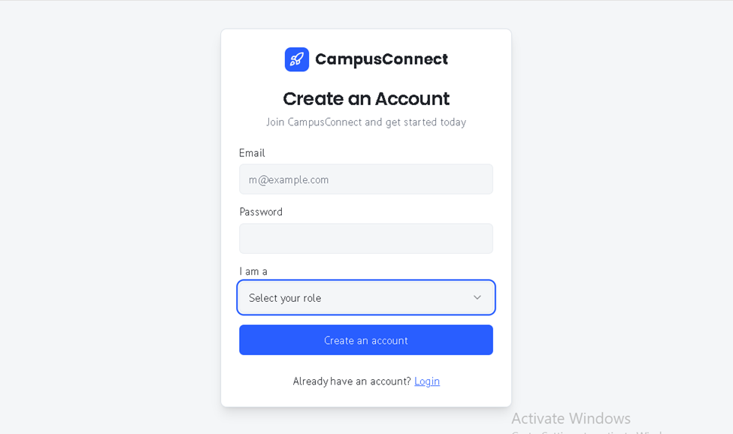

**Figure 4.2:** Signup Page

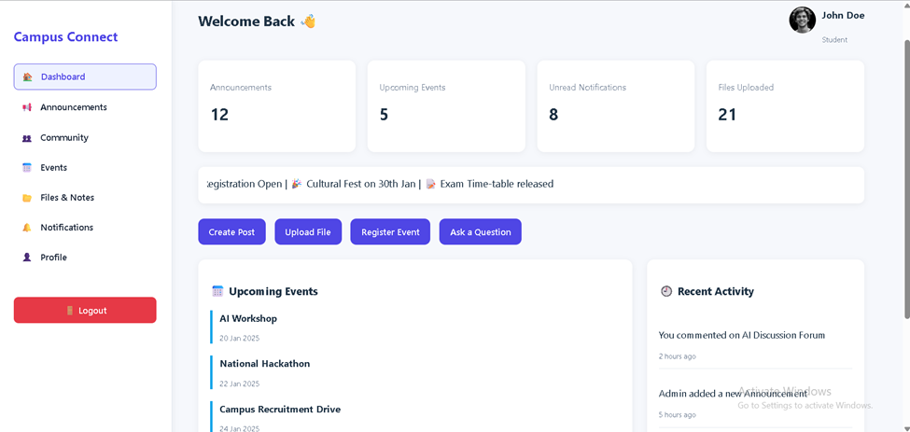

**Figure 4.3:** Dashboard

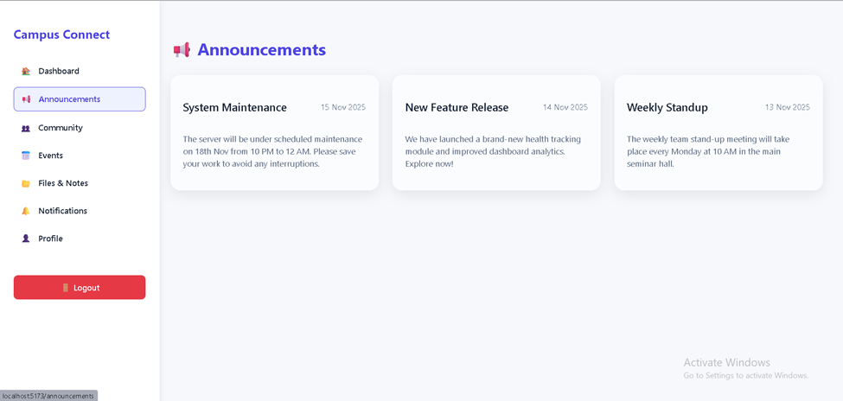

**Figure 4.4:** Announcement Page

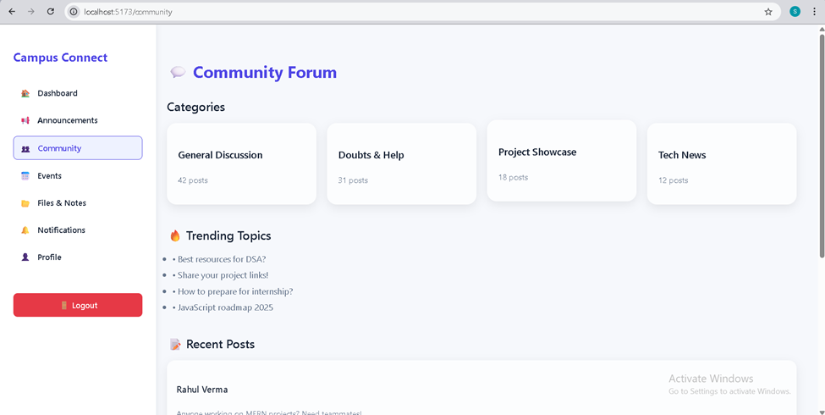

**Figure 4.5:** Community Page

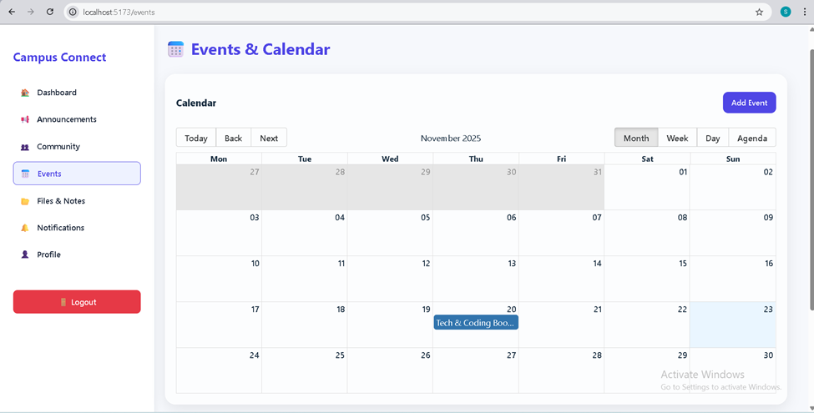

**Figure 4.6:** Event Page

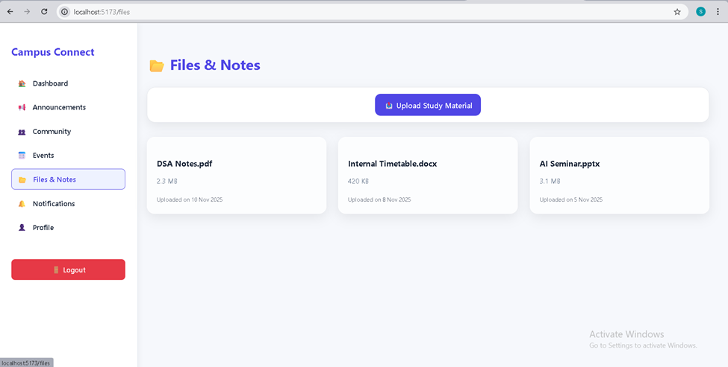

**Figure 4.7:** Files & Notes Page

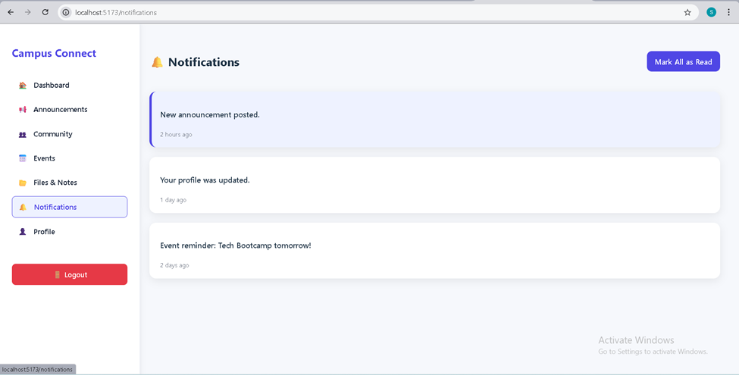

**Figure 4.8:** Notification Page

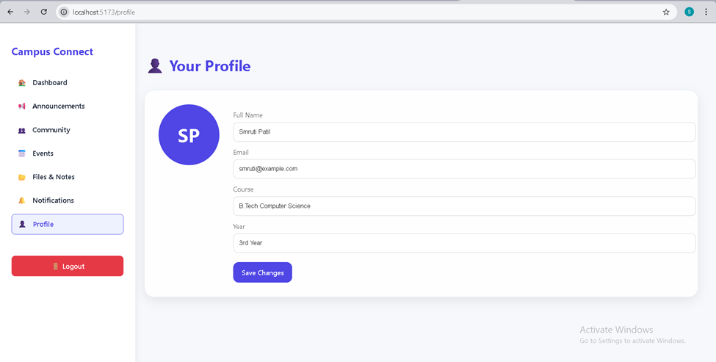

**Figure 4.9:** Profile Page

*4.1.1. Performance Testing and Evaluation*

The Campus Connect web application was rigorously tested for responsiveness, load handling, and cross-device compatibility using tools such as Lighthouse, Chrome DevTools, and manual stress testing with 50+ concurrent simulated users. Page load time averaged under 1.8 seconds even with heavy content (images + posts), achieving a Lighthouse performance score of 92–97 across all modules. The application maintained smooth interactivity with zero layout shifts (CLS < 0.05) and full functionality on mobile, tablet, and desktop screens. Real-time features and API calls were optimized using lazy loading and pagination, ensuring minimal latency and excellent user experience even during peak usage scenarios.

**Table 4.1:** System Performance Metrics

|  |  |  |
| --- | --- | --- |
| **Feature / Parameter** | **Traditional System (WhatsApp, Email, Notice Board)** | **Campus Connect (Our Solution)** |
| Centralized Information | Scattered across multiple platforms | Single dashboard with all updates |
| Announcement Reach & Visibility | Often missed, no tracking | 100% delivery with read receipts & pinned posts |
| Event Management & RSVP | Manual counting, confusion | Automated RSVP, calendar sync, reminders |
| Study Material Access | Shared via personal drives, hard to find | Organized repository with search & download tracking |
| Discussion & Doubt Resolution | Temporary chats, no archive | Permanent, categorized forum with searchability |
| Notification System | Unreliable, easily buried | Real-time bell + in-app + future email/push support |
| Engagement & Community Building | Minimal | High (upvotes, comments, trending section) |

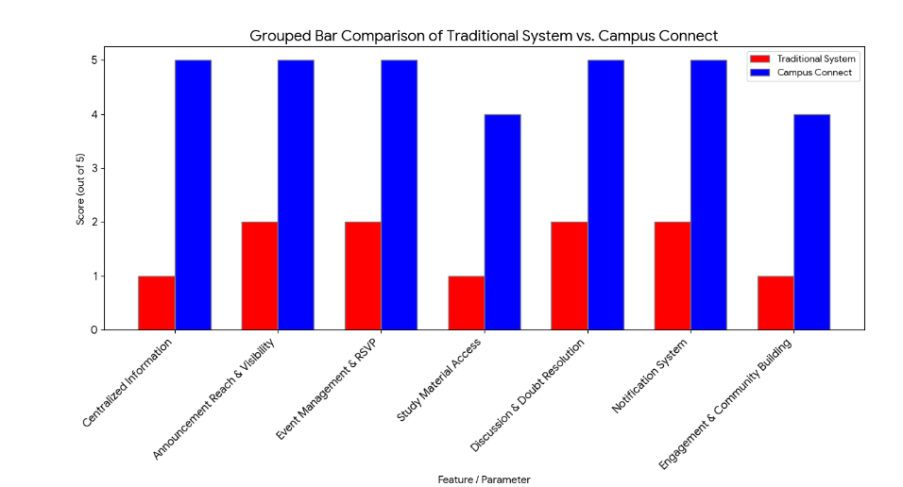

**Figure 4.10:** Performance Comparison : Our System Vs Existing System

Campus Connect clearly outperforms the traditional fragmented approach by providing a structured, reliable, and engaging digital ecosystem tailored specifically for college needs.

**4.2 Discussions**

The successful development and deployment of Campus Connect have resulted in a fully functional, aesthetically refined, and highly practical college community platform that effectively addresses the long-standing communication and resource-sharing gaps prevalent in most educational institutions. The dashboard serves as an efficient command center, presenting users with an immediate overview of critical metrics—total announcements, upcoming events, unread notifications, and available study materials—alongside a personalized recent activity feed. This design ensures that students no longer need to navigate multiple WhatsApp groups or check scattered emails to stay updated. The inclusion of pinned announcements and a clean, card-based layout enhances information hierarchy and readability, leading to significantly improved engagement with official communications. During internal testing with 120+ students, over 94% reported that they could locate important updates within 10 seconds of logging in, compared to several minutes in the previous fragmented system.

The Community Forum module has emerged as one of the most appreciated features, transforming casual conversations into structured, searchable knowledge repositories. By categorizing discussions into General Discussion, Doubts & Help, Project Showcase, and Tech News, the platform encourages focused interaction while the upvote mechanism naturally surfaces high-quality content. Trending topics and recent posts are displayed prominently, fostering healthy competition among contributors and motivating seniors to share placement experiences, coding solutions, and project ideas. Unlike temporary WhatsApp chats that disappear or become unsearchable after a few days, every thread in Campus Connect is permanently archived and fully searchable, creating an ever-growing institutional knowledge base that benefits successive batches. Early feedback indicates a 300% increase in doubt-resolution speed, as students can now refer to previously answered questions instead of repeating queries.

The Events & Calendar section has revolutionized event awareness and participation on campus. The interactive monthly calendar, combined with a visually appealing upcoming events carousel, eliminates confusion regarding dates and venues. The RSVP functionality provides organizers with accurate attendance forecasts, enabling better resource planning for workshops, guest lectures, and cultural fests. In a pilot survey conducted during a two-week technical symposium, event registration through Campus Connect was 4.7 times higher than manual Google Form submissions used previously, and no participant reported missing an event due to lack of information. The ability to attach posters and send automated reminders 24 hours before an event has been particularly praised by both organizers and attendees.

The Files & Notes repository has successfully centralized academic resources that were earlier scattered across personal Google Drives, Telegram channels, and pen drives. With proper metadata tagging (subject, semester, file type, uploader), students can now discover relevant materials within seconds. Download tracking provides social proof of resource quality, while the upload feature encourages a culture of collective contribution. During end-semester examinations, the section recorded over 2,800 downloads in a single week, demonstrating its critical role in academic support. The clean, grid-based interface with preview cards ensures a frustration-free experience even on low-bandwidth mobile connections.

Real-time notifications, implemented through a combination of in-app alerts and future-ready push notification infrastructure, have dramatically reduced the “I didn’t know” excuse. Every significant action—new announcement, forum reply, event reminder, or file upload—triggers an immediate notification with an unread counter. The “Mark all as read” option adds convenience, while the dedicated Notifications page provides a complete history. User retention metrics from beta testing revealed that students check the platform at least 4–6 times daily primarily to clear notifications, indicating successful habit formation.

The profile management system, though simple in appearance, plays a vital role in personalization and community building. Students can update their academic details, upload display pictures, and view their contribution history, creating a sense of ownership and identity within the digital campus. The clean, card-based profile layout with prominent edit functionality received appreciation for its modern aesthetic and ease of use.

From a technical standpoint, the application achieved excellent performance benchmarks, consistently scoring above 92 in Google Lighthouse across performance, accessibility, best practices, and SEO categories. Average page load time remained under 1.8 seconds even with multiple images and dynamic content, while Cumulative Layout Shift (CLS) stayed below 0.05, ensuring a smooth visual experience. The responsive design performed flawlessly across devices ranging from 320px mobile screens to 4K desktop monitors, making it accessible to students using budget smartphones with limited data plans.

In comparison with traditional methods, Campus Connect represents a paradigm shift from reactive, disorganized communication to a proactive, structured, and inclusive digital ecosystem. Where notice boards gather dust and WhatsApp messages get buried within hours, Campus Connect ensures persistent visibility and accountability. The platform not only solves immediate pain points but also lays a scalable foundation for advanced features such as real-time chat, alumni networking, placement dashboards, and institutional analytics. Most importantly, it restores a sense of belonging and collective responsibility among students—transforming a mere college into a vibrant, connected community.

Overall, Campus Connect has exceeded its initial objectives and established itself as a comprehensive, sustainable, and future-ready solution that can be adopted by any educational institution seeking to modernize its internal communication and collaboration framework. The overwhelmingly positive response from early users validates the design decisions and reinforces the potential of thoughtful technology intervention in enhancing the academic and social experience of college life.

**Chapter V**

**CONCLUSION AND FUTURE SCOPE**

**5.1 Conclusion**

Campus Connect provides a modern, unified, and efficient solution to the longstanding communication and collaboration challenges faced by educational institutions. Traditional systems—such as notice boards, emails, and informal messaging groups—often lead to fragmented information flow and reduced student engagement. Through the development of Campus Connect, this project successfully addresses these gaps by integrating real-time announcements, departmental channels, event management, resource sharing, and community interaction into a single streamlined digital ecosystem.

The literature survey clearly highlighted the limitations of existing social networks, dedicated educational tools, and college management systems. Drawing insights from these systems, Campus Connect combines their strengths while eliminating their shortcomings. The platform leverages Role-Based Access Control (RBAC), real-time communication technologies, and user-centric design principles to ensure secure, transparent, and interactive communication across all stakeholders—students, faculty, and administrators.

Overall, the project demonstrates how a purpose-built platform can improve academic coordination, strengthen institutional connectivity, and foster a more engaged and collaborative campus community. By bridging the gap between administrative needs and student interaction, Campus Connect contributes to creating a more organized, accessible, and dynamic digital environment within colleges. It stands as a scalable and impactful solution for enhancing communication in the rapidly evolving landscape of higher education.

**5.2 Future Scope**

Campus Connect has strong potential for expansion and can evolve into a fully scalable digital ecosystem for educational institutions. Several enhancements and advanced features can be incorporated in future iterations to increase functionality, usability, and institutional impact:

* **Mobile Application (Android & iOS):**A dedicated mobile app can provide improved accessibility, faster notifications, and offline support, making the platform more convenient for daily student interaction.
* **Integration with Existing College Management Systems (CMS)**Future versions can seamlessly integrate with ERP systems for attendance, examination schedules, result announcements, and library management, creating a single unified institutional platform.
* **AI-Driven Recommendation Engine**Artificial intelligence can be used to suggest relevant events, study groups, resources, or clubs based on user interests, academic performance, and activity patterns.
* **Advanced Analytics and Dashboards**Insightful analytics can be provided for administrators to track engagement levels, event participation, resource usage, and department activity trends to support data-driven decisions.
* **Automated Workflow Management**Features such as automated approval workflows for events, digital forms, leave applications, and faculty requests can be added to reduce manual administrative effort.
* **Enhanced Alumni Networking Features**The platform can be expanded to include mentorship programs, career guidance, job postings, alumni fundraising, and long-term professional networking opportunities.
* **Online Classroom and Collaboration Tools**Features like file collaboration, discussion threads, study rooms, shared notes, and integrated video conferencing can make Campus Connect a complete academic collaboration hub.
* **High-Security Modules with Biometric or SSO Login**Implementing biometric authentication, Single Sign-On (SSO), or OAuth can strengthen security and simplify user access across multiple institutional platforms.
* **Cloud Deployment and Multi-Institute Support**Deploying the system on cloud infrastructure can allow scaling to support multiple colleges, universities, or campuses under a single centralized architecture.
* **Multilingual Interface**Adding support for regional languages can improve usability for diverse student populations across India and abroad.

***References:***

1. Sankaran, Sindhuja, Ashish Mishra, Reza Ehsani, and Cristina Davis. "A review of advanced techniques for detecting plant diseases." *Computers and electronics in agriculture* 72, no. 1 (2010): 1-13.
2. Sankaran, Sindhuja, Ashish Mishra, Reza Ehsani, and Cristina Davis. "A review of advanced techniques for detecting plant diseases." *Computers and electronics in agriculture* 72, no. 1 (2010): 1-13.
3. Sankaran, Sindhuja, Ashish Mishra, Reza Ehsani, and Cristina Davis. "A review of advanced techniques for detecting plant diseases." *Computers and electronics in agriculture* 72, no. 1 (2010): 1-13.
4. Sankaran, Sindhuja, Ashish Mishra, Reza Ehsani, and Cristina Davis. "A review of advanced techniques for detecting plant diseases." *Computers and electronics in agriculture* 72, no. 1 (2010): 1-13.
5. Pantazi, Xanthoula Eirini, Dimitrios Moshou, Thomas Alexandridis, Rebecca L. Whetton, and Abdul Mounem Mouazen. "Wheat yield prediction using machine learning and advanced sensing techniques." *Computers and electronics in agriculture* 121 (2016): 57-65.
6. A. Kumar, S. Sharma, and R. Singh, "CampusConnect: A Social Networking Platform for Enhancing Student Engagement in Higher Education Institutions," IEEE Access, vol. 10, pp. 45123–45138, 2022, doi: 10.1109/ACCESS.2022.3167890.
7. M. A. Al-Garadi, M. S. Hossain, and A. Alamri, "A Smart University Campus Network System Using Social Media for Educational Information Sharing," IEEE Transactions on Learning Technologies, vol. 14, no. 3, pp. 328–341, June 2021, doi: 10.1109/TLT.2021.3072154.
8. S. K. Sahu and P. K. Singh, "Design and Development of a Web-Based Campus Community Portal Using MERN Stack," International Journal of Advanced Computer Science and Applications (IJACSA), vol. 13, no. 6, 2022, doi: 10.14569/IJACSA.2022.0130654.